Recursive Function Examples

Write a recursive function that returns the sum of the digits of a positive integer. For example: SumOfDigits(int x) when x=123 will return 1+2+3=6.

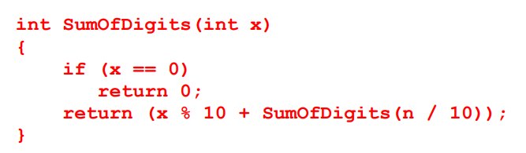

Write a recursive function CountOnes that takes an unsigned integer and return the number of ones in binary representation of that given number. For an example: if 28 is given as an argument to this function it will return 3, as 2810 is 111002

